Assignment 8: Double and Multiple-Slit Interference
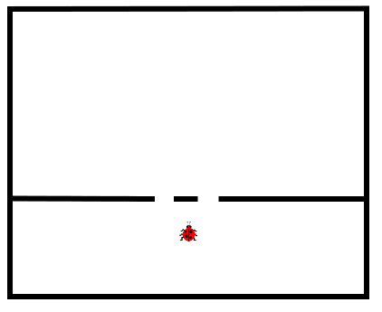
- A bug falls in a pool of water that has a divider in it, as shown in the picture. The distance between the two openings is 7 cm. The distance from the divider to the far wall is 35 cm. As the bug swims, it makes waves that travel at a speed of 2 m/s, and have a frequency of 22 Hz.
  - What is the wavelength of the waves made by the bug?

  - Sketch the shape of the waves that the bug makes. Include the waves that pass through the openings in the barrier.

  - Of the waves that hit the far wall, the largest ones occur at the center. How far from the center is the first region of smallest waves?

  - How far from the center is the region of next-largest waves?

- A laser has a wavelength of 6.3 x 10⁻⁷ m. It shines on a piece of metal with two small holes drilled in it. The separation of the holes is 1 x 10⁻⁴ m. A screen is placed 3 meters away. What is the distance from the central bright spot to the third-order bright spot?

- In a young's double slit experiment, the wavelength of light used is 550 nm. The separation between the slits is 1.4 x 10⁻⁶ m.
  - Determine the angle that locates the center of the first dark spot.

  - The angle that locates the second bright spot.

  - The angle that locates the third bright spot.

- In a Young's double slit experiment, the separation between the first-order bright fringe and the second-order bright fringe is 0.007 m when the wavelength of light is 400 nm. Find the separation between the two fringes when the wavelength is 600 nm.

- Light of λ=410 nm (in a vacuum) is incident on a diffraction grating that has a lines separated by a distance of 1.5 x 10⁻⁶ m. The diffraction grating is 0.15 m from the viewing screen.
  - Find the separation distance from the central bright spot to the third bright spot.

  - The entire apparatus is submerged in water. (n = 1.33). What is the new distance to the third bright spot?

